Bharata Nrityam performance at The Indian Consolate –New York

Bala Devi Chandrashekar, Senior disciple of the noted Bharata Nrityam exponent Dr. Padma Subrahmanyam delivered an informative, content rich Lecture- Demonstration cum performance of Bharata Nrityam on March 23rd hosted by Honorable Consul General Neelam Deo, as part of a series of events at the Indian Consulate to celebrate the age old traditions of Indian dance and music. The performance was attended by Academicians and practitioners of performing arts from the Tri-State region.

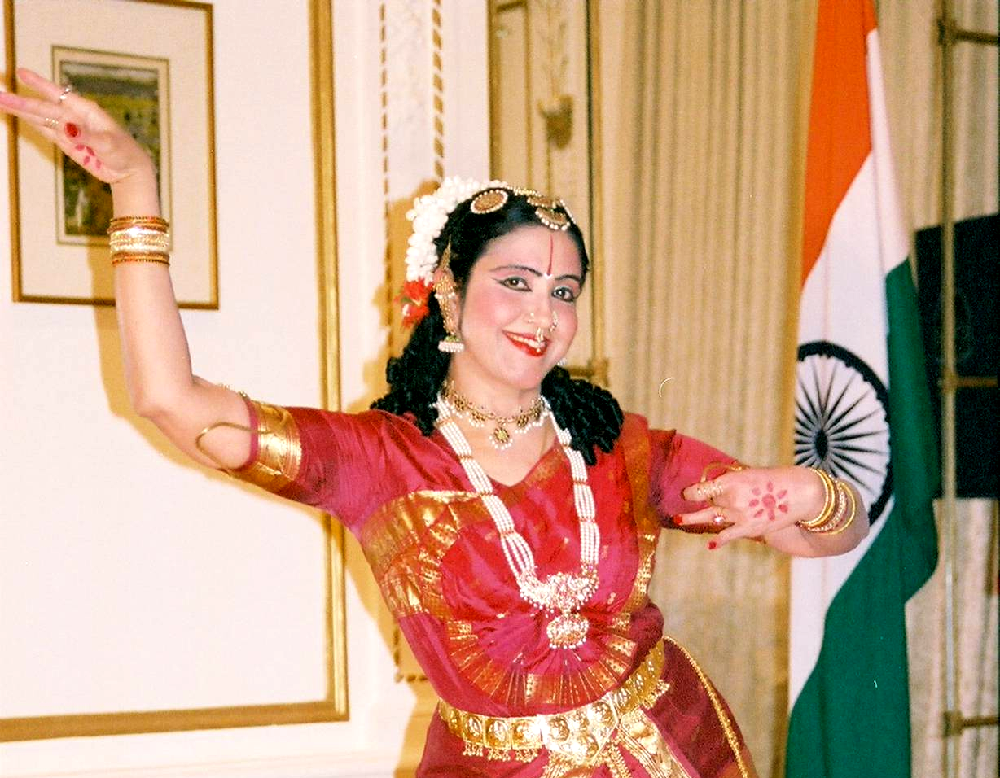

Bala danced with remarkable dedication and involvement. Her fine grip and skill in aspects of laya were seen in the invocatory Pushpanjali in Arabhi and other Nritta numbers, bringing out the execution of intricate rhythmic patterns with felicitous grace and sparkle.

The Abhinaya for the lyrical content of the Shringara and devotional padams were treated with appropriate facial expression. Her Angika Abhinaya movements transcended the mundane, as her expression were evocative. Bala’s exhilarating performance held the audience captive through the program.

As part of the post performance discussion, Bala shared her knowledge based on her Guru Dr. Padma Subrahmanyam’s scholarly research and study of Natya Shastra and emphasized the importance of studying and imbibing the technique that Natya shastra offers. Bala gave valid and appropriate explanation for questions from the audience on issues of connectivity between the artist and the onlooker, the common cultural ethos of Asia etc. Through her performance and talk Bala reiterated her Guru Dr. Padma Subrahmanyam’s research in bridging the gap between theory and practice and the margi tradition being a strong source of inspiration to contemporary practice in Indian classical dance.

Deepa Limaye
joshideepa@hotmail.com

